Title: Dystopia

Key Question:

1: Is society something helping us to build or destroy ourselves?

2: To what extent can people realize (become aware of) that they are living in a dystopian world.

3: To what extent can a utopian world be seen as dystopian

4: To what extent can dystopia be hiding behind Utopia!

5: Dystopia: self-Builder or self-Destroyer?

6: Society: self-Builder or self-destroyer?

# Of mice and men (George shoots Lennie)

## When George shoots Lennie:

Lennie said craftily- "Tell me like you done before."

"Tell you what?"

"'Bout the other guys an' about us."

George said, "Guys like us got no fambly. They make a little stake an' then they blow it in. They ain't got nobody in the worl' that gives a hoot in hell about 'em-"

"But not us," Lennie cried happily. "Tell about us now."

George was quiet for a moment. "But not us," he said.

"Because--"

"Because I got you an'-"

"An' I got you. We got each other, that's what, that gives a hoot in hell about us," Lennie cried in triumph.

The little evening breeze blew over the clearing and the leaves rustled, and the wind waves flowed up the green pool. And the shouts of men sounded again, this time much closer than before.

George took off his hat. He said shakily, "Take off your hat, Lennie. The air feels fine."

Lennie removed his hat dutifully and laid it on the ground in front of him. The shadow in the valley was bluer, and the evening came fast. On the wind the sound of crashing in the brush came to them.

Lennie said, "Tell how it's gonna be."

George had been listening to the distant sounds. For a moment he was businesslike. "Look acrost the river, Lennie, an' I'll tell you so you can almost see it."

Lennie turned his head and looked off across the pool and up the darkening slopes of the Gabilans. "We gonna get a little place," George began. He reached in his side pocket and brought out Carlson's Luger; he snapped off the safety, and the hand and gun lay on the g ound behind Lennie's back. He looked at the back of Lennie's head, at the place where the spine and skull were joined.

A man's voice called from up the river, and another man answered. "Go on," said Lennie. George raised the gun and his hand shook, and he dropped his hand to the ground again.

"Go on," said Lennie. "How's it gonna be.

We gonna get a little place."

"We'll have a cow," said George. "An' we'll have maybe a pig an' chickens... an' down the flat we'll have a... little piece alfalfa-"

"For the rabbits," Lennie shouted.

"For the rabbits," George repeated.

"And I get to tend the rabbits."

"An' you get to tend the rabbits."

Lennie giggled with happiness. "An' live on the fatta the lan'."

"Yes."

Lennie turned his head.

"No, Lennie. Look down there acrost the river, like you can almost see the place."

Lennie obeyed him. George looked down at the gun.

# Explaining of Mice and men

When Lennie accidentally killed Curley’s wife, he destroyed at the same time the light, the hope, the dream that they both had about owning their own farm and their own animals. The moment George realizes what Lennie has done; he knows that the hardest task is yet to come. Kill Lennie. He who had sworn an oath to protect Lennie as much as he could, had to, to save Lennie, kill him before Curley does it. This is an example of when society destroys you because it retracts the slightest hope you had.

# 1984 – George Orwell

## Part I, Chapter 1

The Ministry of Truth – Minitrue, in Newspeak – was startlingly different from any other object in sight. It was an enormous pyramidal structure of glittering white concrete, soaring up, terrace after terrace, three hundred meters into the air. From where Winston stood it was just possible to read, picked out on its white face in elegant lettering, the three slogans of the Party:

WAR IS PEACE

FREEDOM IS SLAVERY

IGNORANCE IS STRENGTH.

The Ministry of Truth contained, it was said, three thousand rooms above ground level, and corresponding ramifications below. Scattered about London there were just three other buildings of similar appearance and size. So completely did they dwarf the surrounding architecture that from the roof of Victory Mansions you could see all four of them simultaneously. They were the homes of the four Ministries between which the entire apparatus of government was divided. The Ministry of Truth, which concerned itself with news, entertainment, education, and the fine arts. The Ministry of Peace, which concerned itself with war. The Ministry of Love, which maintained law and order. And the Ministry of Plenty, which was responsible for economic affairs. Their names, in Newspeak: Minitrue, Minipax, Miniluv and Miniplenty.

# Explaining The extract of part I chapter 1 from 1984

This extract give an example of the extent that can be put into action to create a completely fake world in which people think that they are living a great life when in reality they are acting exactly as the only party expects them to. This party modifies history to the extent that it is impossible to know the truth from the lies. Add to this the constant destruction of proof and the motto under each banner that are everywhere in the city, “war is peace/freedom is slavery/ignorance is strength.”. if we Don’t forget that they are creating a new, extremely simplified language named newspeak who’s aim is to prevent any possibility of it’s people to rebel, (due to lack of varied language and thus the capability of expressing themselves) and there you go, they cannot express will of rebelling unless they use their fists.

# Literary text 3: The importance of being Ernest (Oscar wild)

ALGERNON: [...] But why does she call herself little Cecily if she is your aunt […][Reading.] “From little Cecily with her fondest love.”

JACK: […] My dear fellow, what on earth is there in that? Some aunts are tall, some aunts are not tall. That is a matter that surely an aunt may be allowed to decide for herself.[…]

ALGERNON: Yes. But why does your aunt call you her uncle? “From little Cecily, with her fondest love to her dear Uncle Jack”. […] Besides, your name isn't Jack at all; it is Ernest.

JACK: It isn't Ernest; it's Jack.

ALGERNON: You have always told me it was Ernest. I have introduced you to everyone as Ernest. You answer to the name of Ernest. You look as if your name was Ernest. You are the most earnest-looking person I ever saw in my life. […]

JACK: Well, my name is Ernest in town and Jack in the country, and the cigarette case was given to me in the country.

ALGERNON: Yes, but that does not account for the fact that your small Aunt Cecily, who lives at Tunbridge Wells, calls you her dear uncle. Come, old boy, you had much better have the thing out at once.

# Explaining the importance of being Ernest:

This part of the play deals with the moment when Jack is forced to reveal his double life and the effect that his position in society has on his behaviour. The choice of the name Ernest for his fictitious brother is ironic given that when he is Ernest he is not earnest at all. In Victorian times earnestness was considered as of the topmost ideals for reforming the lower classes. Later on, it spread to the upper class as well. The very subtitle of the play ‘A Trivial Comedy For Serious People’ shows the theme. The play ridicules Victorian customs and traditions, marriage and particularly the pursuit of love. It aims to highlight the hypocrisy of Victorian society and its double standards.

# Joker: A Powerful Psychological Drama

## Arash Javanbakht M.D.

### Beginning: A Sad Child and a Man Lost in Chaos

Arthur is deeply sad and confused. His job contradicts his feelings, which he hides behind the makeup. He was beaten up by others, physically and emotionally, all his life. Every day he came home to take care of a mother who was not able to care for him when he was a child. A mother who had raised him in a distorted reality: Things are good although they are terrible. Arthur is deeply confused about his place in the world, what is real, and what is fantasy.

When alone, Arthur is most of the time naked, a clear contrast to his daily life hiding behind a mask. He does not have a sense of identity; instead, he is empty. He colors his emptiness with makeup, and his deep agony with a fake smile drawn on his face. Then, are the terribly untimely, annoying, and agonizing laughter attacks.

### Agony, Fake Smiles, and Crazy Laughter

Joaquin Phoenix does a great job of portraying Arthur’s deep agony and inviting the viewer inside the chaos of his shattering mind. That makes this movie hard and painful to watch. Every time Arthur tries to step outside of his inner painful world and connect with others, even as a clown, or a stand-up comedian, his unpredictable laughter attacks claw him back into the pain within.

The laughter is perceived as a disease, maybe a tic, or a neurological condition. A psychoanalyst, though, could have a different interpretation: a defense mechanism. We later learn that Arthur was severely abused and neglected during childhood, leading him to hardwired suffering and developing a sense of a ruthless and sad universe.

In the state hospital, flashbacks to Arthur’s mother’s interview with a psychiatrist reveal that his delusional mother had totally ignored Arthur’s pain during his childhood, and always thought he was a happy child. Parents not only form a large part of our perception of the universe, but also that of ourselves.

Little Arthur was terribly confused: I am very sad, suffering physical and mental pain, but Mom says I am happy, and probably expects me to be happy. This leads to a duality of Arthur’s character: The inside and outside worlds do not, and will not, match.

This all may explain his choice of a job where he looks happy to others and tries to make them happy while suffering deep inside. And the crazy laughter: an overflow of the reactive defense, a scream of happiness that satisfies Mom, and simultaneously repels her and others. It protects Arthur from the outside world, as it pulls him back into his inner abyss, curling into himself. The laughter blocks every attempt of connecting with the outside world, which is perceived by his inner child as deceitful and brutal, even if looking nice on the surface. The laughter protects him from the world he perceives.

### What Is Real and What Is Not?

Between his and his mother’s delusions, it is impossible for Arthur to determine reality from fantasy. Per the mother, he is the son of a famous man and the result of a glorified secret romance. It is at the state hospital that the beautiful fantasy world, his reality, is shattered.

He learns that his mother is psychotic, he was adopted, and was seriously abused and neglected by mother’s boyfriend. This confusion about what he can or cannot rely on, and what is going to hurt him, creates tremendous vulnerability, anger, and sadness. Next is killing, in order to become.

### The Becoming

The revelation at the hospital is a moment of awakening, not only to the facts but also of the childhood programming. He becomes a man, in a very sad way.

Boys learn how to be a man from male figures, mostly the father. Here, the man—mom’s boyfriend—was brutal and abusive, and that is what Arthur becomes: He identifies with the aggressor. The other option, Thomas Wayne, is not an option anymore, as he now knows Wayne is not his father.

He becomes the violent ruthless man, the father, while still fulfilling mother’s wish: a smiling clown. He kills his mother, his anchor in the unreal, the beautiful fantasy world, the big lie. Then he launches into killing his anchors of hope in the real world: the lady next door he likes, his fantasies for a nurturing relationship he never had, potentially a family; his friend and colleague, a symbol of a career; and Murray Franklin, another praised father figure, the connection between Arthur and his mother, between Arthur and his career ambition, and a presentation of goodness. Joker kills what he cannot have, and cannot be, and disconnects.

Arthur becomes not who he was born to be, but who he was raised to be — a victim of parents’ wishes and actions who is dead and hurting inside, with a big fake smile for the outside world and the mother. It is natural for him to hurt and kill, because to him, the world is an evil lie, and he shares himself with this world: dead inside, and tormented.

Joker is a hard movie to watch.

# Explaining article, The Joker the psychiatrist

The Joker is a complex personality that has shifting feelings. He will slowly shift Identity and thus character behavior. The paths toe this new, dangerous identity is bloody. He has to cut bounds with the people he used to be attached to, or his mother, whom, he learns later on has a psychological condition that did that the world in which he though he grew up in was actually the complete opposite of the reality. He learns that he was abused by he biological father and thus, it explains part of all the killing he did.

# The Truman Show

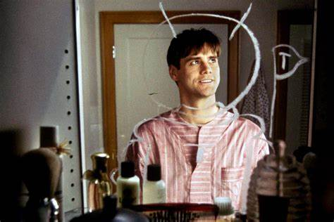

# The reason why I chose the Truman Show

I chose the Truman show, because I find that although he thinks he lives in the real world, he realizes little by little that it is a made-up world and thus, tries to escape. The present image is what Truman does every morning in the bathroom of the invented world. An astronaut (him) planting a flag with his name on a new imaginary territory, his mirror. This created world, in which his job is to be an actor in plays is in itself a “mise en abime” because his life is a play in itself.

# Goodbye Lenin!

## Wolfgang Becker

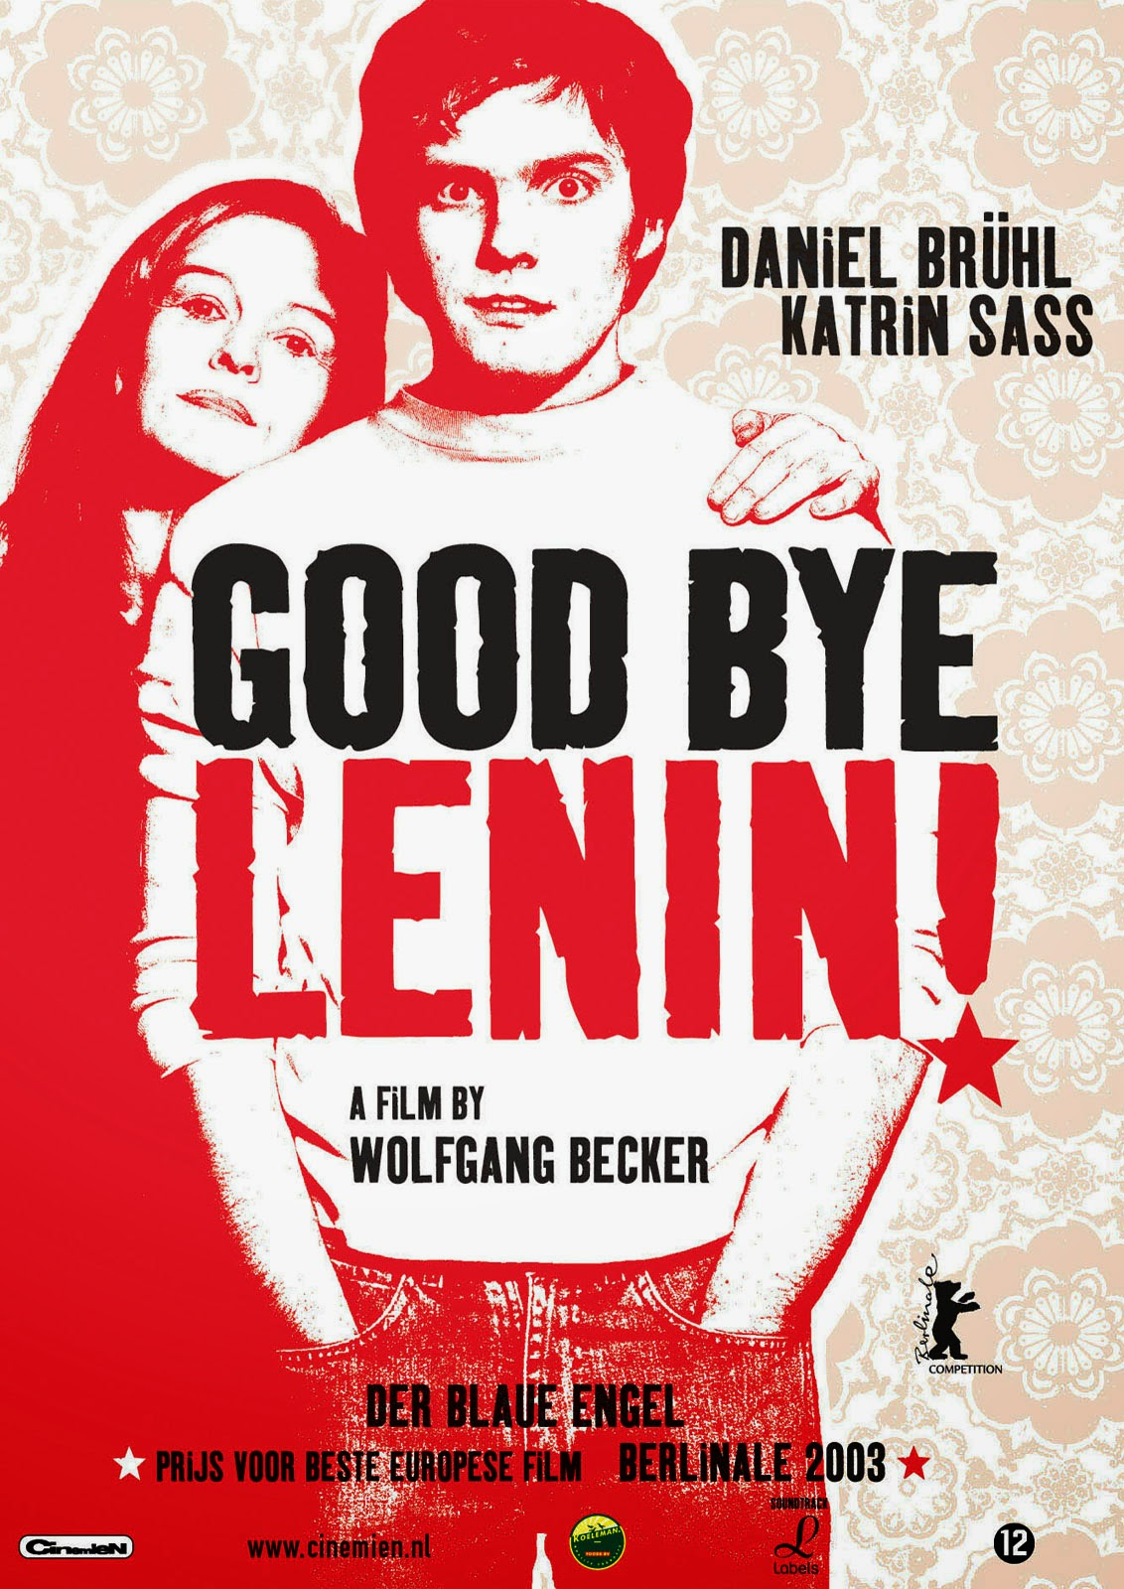

# Why I chose Goodbye Lenin:

I find that goodbye Lenin is a good example of society being able to destroy you while giving you the impression that you are building yourself. As a mater of fact, the narrators mother, even if she knows that the regime she lives in is a dystopian world, she still decides to adapt to it and when she fall in the her first comma, that will last until the end of the regime, her eldest son will lie to her by letting her believe that the communist regime is still in place. He did this out of fear of loosing his mother forever.

**To Conclude:**

Society can help you build yourself as it can destroy you. As seen in the previous documents, some have tried to rise but then fallen and others have chosen to fall. When facing the truth, it isn’t always easy to get back up when you realize that all you thought was real and all you thought you had was a complete or partial lie.

# Credits:

Mind map (created by me): <https://mm.tt/1705168786?t=SJMt48j3uG>

Of mice and men (When George shoots Lennie): <https://archive.org/details/in.ernet.dli.2015.507266/page/n183/mode/2up>

George Orwell – 1984 (Part I, Chapter 1): <https://archive.org/details/1984GeorgeOrwell_201810/mode/2up>

The joker (analysis): <https://www.psychologytoday.com/us/blog/the-many-faces-anxiety-and-trauma/201911/joker-powerful-psychological-drama>

The Truman Show (extract of the morning scene) : <https://th.bing.com/th/id/OIP.B2x04OSurQpiffiAfvkcuQHaE8?pid=Api&rs=1>

Charlie Chaplin – Modern Times (cover): <https://upload.wikimedia.org/wikipedia/commons/3/36/Modern_Times_poster.jpg>

Goodbye Lenin (cover) : <https://4.bp.blogspot.com/-ewh93Wg7Glw/VBp_gKE9R3I/AAAAAAAANeE/GZmvuW8j2qI/s1600/goodbye-lenin%2Bposter.jpg>

Dystopia

To what extent cans we stay in utopia without falling into dystopia ?

The good place

The handmaid’s tale

Vica versa

Death of a salesman

Twelve angry men

Wages of fear

Black miror – Down hill

Dismaland/Disney land

The Members of the NSKK group: the before and d-date of the Krystal nacht : <https://mm.tt/1674301675?t=KrqzWlSl6R>

Utopia Thomas More

The prisoner

1984 – George Orwell

Annimal Farm

Opening: Can Ustopia be the summary of Dystopia and Utopia